BOWA
Science Inquiry Skills

Foundation Skills Scientific Methodology Skills
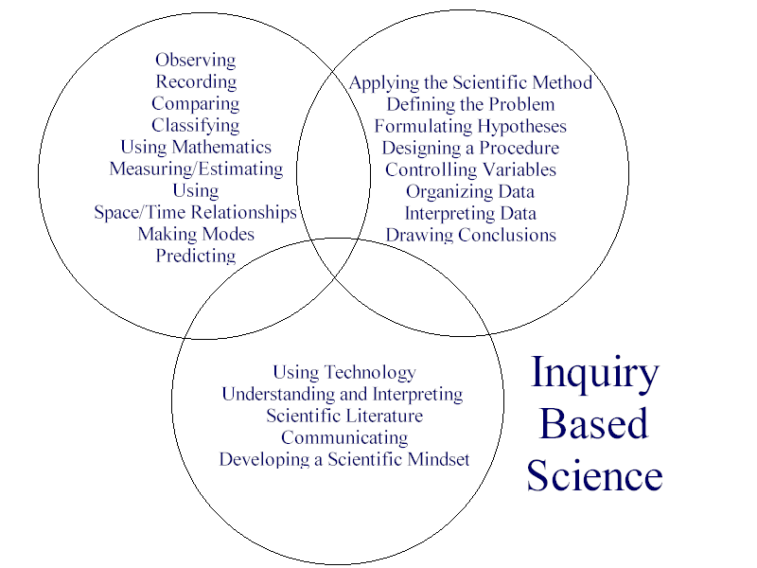
Science Toolkit Skills

